**Saisha Kashyap - Progress Report**

**Machine Learning**

Completed the first week and am midway through the second week of the Machine Learning course offered by Stanford University on Coursera. The first week is an introduction to the topic and includes the algorithm for univariate linear regression.

The course divides machine learning algorithms into two broad categories- Supervised and Unsupervised learning. It also talks about regression and classification problems under supervised learning.

Under linear regression, hypothesis function and cost function are discussed. Our objective is to minimise the cost function and this is achieved by gradient descent.

In gradient descent, we start with some arbitrary value of parameters and keep changing them to reduce cost function, until we end up at a minimum.

Following is the algorithm for gradient descent:

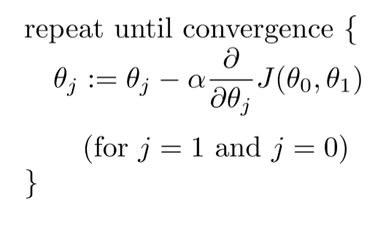

Where a(alpha) is the learning rate and the derivative is the differentiated cost function. Alpha should be optimum. If it is too small, gradient descent will be slow. If it’s too large, gradient descent can overshoot the minimum. After each iteration j, the parameters are simultaneously updated.

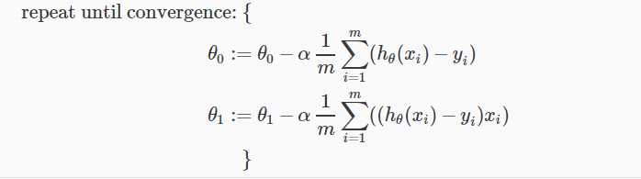Algorithm of gradient descent for linear regression in one variable:

In the second week, till where I have reached, the course talks about multivariate linear regression. Algorithm of gradient descent for multivariate linear regression is as follows:

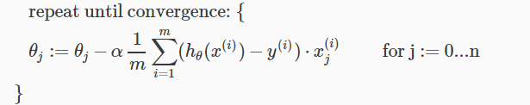

The course also talks about feature scaling and mean normalization which are techniques to scale the input variables into an appropriate range.

**Python**

Finished course 1 (received certificate) and the first couple of weeks of course 2 of 5 - Python for Everybody (offered by University of Michigan) on Coursera.

Course 1: Includes sequential, conditional and iterative operations, functions

Attached some of the codes.